**Visit Georgia site**

1. **Introduction**

This website will be a tourism website for the country of Georgia. The website will include the navigation bar, footer, carousels, tabs, jumbotron, media objects, videos, map, time and weather widgets. The images and description about tourism in Georgia will be stored in the separate datafiles, which will be imported into main React Component and passed to its siblings via props.

* 1. *The Homepage*
     1. **The Navbar**
        1. The Visit Georgia webpage has a simple and user-friendly navigation bar conveniently located at the top of the page. It will remain at the top of the screen even as the user scrolls down the page.
     2. **The Carousel**
        1. The webpage contains a screen-width carousel with four beautiful images of four major tourist destinations of Georgia.
     3. **The Jumbotron with changing title feature**
        1. Under the Navbar, the user will find a jumbotron with the heading, “Welcome to Georgia: [title]”. As the user scrolls through the carousel images, the title will change with the photos reading, “Welcome to Georgia: Tbilisi”, “Welcome to Georgia: Alaverdi”, “Welcome to Georgia: Batumi”, “Welcome to Georgia: Korbuleti”.
     4. **Tabbed Information**
        1. Below the carousel, the user will find tabbed information regarding Georgia. The three tabbed sections are:
           1. About Georgia

Here the user can read a brief description of the country

* + - * 1. Map

By clicking on this tab, the user may view an interactive map of Georgia

* + - * 1. Currency

By navigating to this tab, the user may view the current exchange rate for the US Dollar to the Georgian Lari.

* + 1. **Weather Widget**
       1. Below the Tabbed Information, the user will find a weather widget that will tell them the current weather information for Georgia’s capital city, Tbilisi.
    2. **Embedded Videos**
       1. Under the weather widget, the user will be able to interact with two embedded videos:
          1. The Statue of Love: Batumi, Georgia
          2. The Most Beautiful Country, Georgia
    3. **Footer**
       1. The homepage will end with a footer containing:
          1. Links to other pages on the site:

Home

Activities

Tours

* + - * 1. Social Icons to follow Georgia on Social Media
        2. A signature crediting the authors of the project
  1. *The Activities Page:*
     1. **The Navbar**
        1. The Visit Georgia webpage has a simple and user-friendly navigation bar conveniently located at the top of the page. It will remain at the top of the screen even as the user scrolls down the page.
     2. **Request More Information Modal**
        1. When the user clicks on the “Request More Information” button, a modal will appear and give the user the option to submit their email address to have a free digital brochure sent to their inbox.
     3. **Heading: What Can You Do in Georgia**
     4. **Carousel: Caves**
        1. An interactive carousel featuring 3 slides with images and hyperlinks
     5. **Carousel: Skiing**
        1. An interactive carousel featuring 2 slides with images and hyperlinks
     6. **Carousel: Tblisi**
        1. An interactive carousel featuring 4 slides with images
     7. **Footer**
        1. The homepage will end with a footer containing:
           1. Links to other pages on the site:

Home

Activities

Tours

* + - * 1. Social Icons to follow Georgia on Social Media
        2. A signature crediting the authors of the project
  1. *The Tours Page:*
     1. **The Navbar**
        1. The Visit Georgia webpage has a simple and user-friendly navigation bar conveniently located at the top of the page. It will remain at the top of the screen even as the user scrolls down the page.
     2. **Media Objects**
        1. The main section of the page includes the following media objects:
           1. Georgia Adventure
           2. Wine in Georgia
           3. Georgian Caucasus Mountain Ski Paradise
           4. Svaneti Highlands
     3. **Footer**
        1. The tours page will end with a footer containing:
           1. Links to other pages on the site:

Home

Activities

Tours

* + - * 1. Social Icons to follow Georgia on Social Media

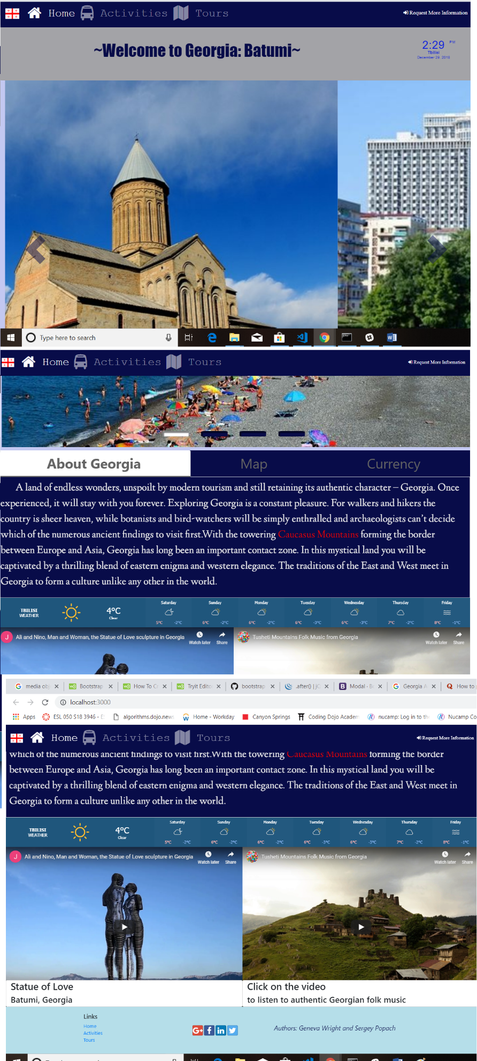

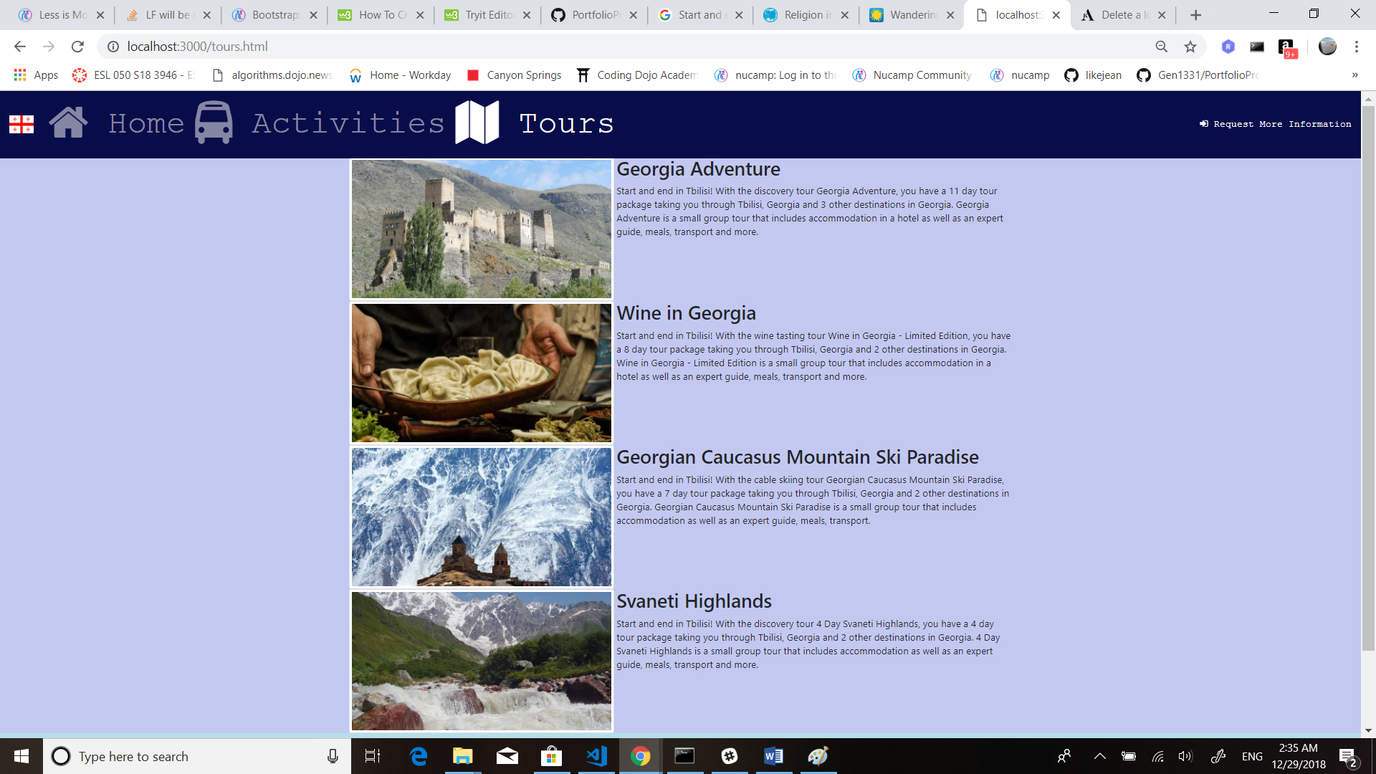

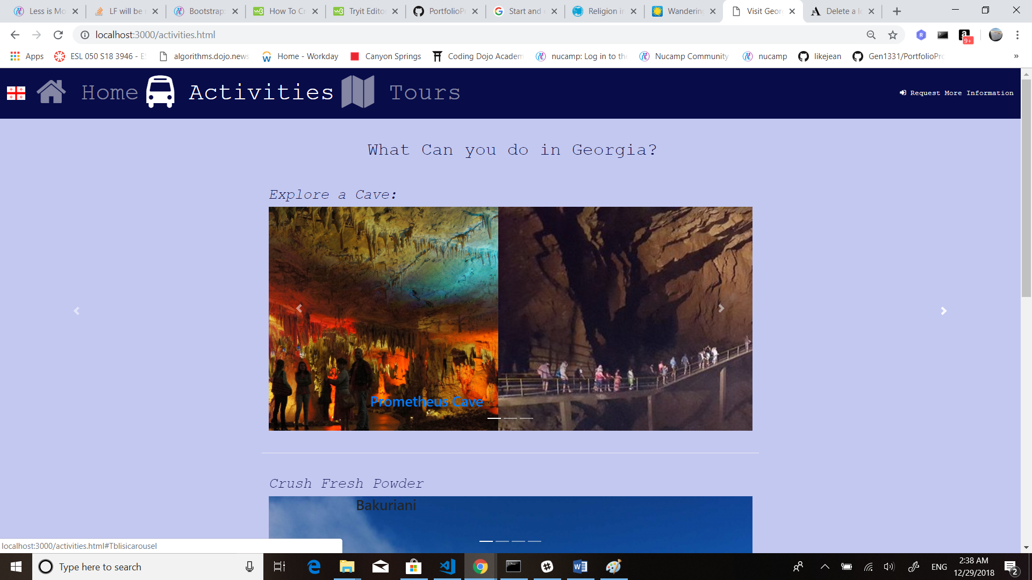

1. **Navigation Structure: User Experience Diagram**

The Main Page of the website will have navigation links, which will allow a user to navigate to Activities Page, Tours Page and Request Additional Information. The UX Diagram below demonstrates how the React Components will be interconnected.

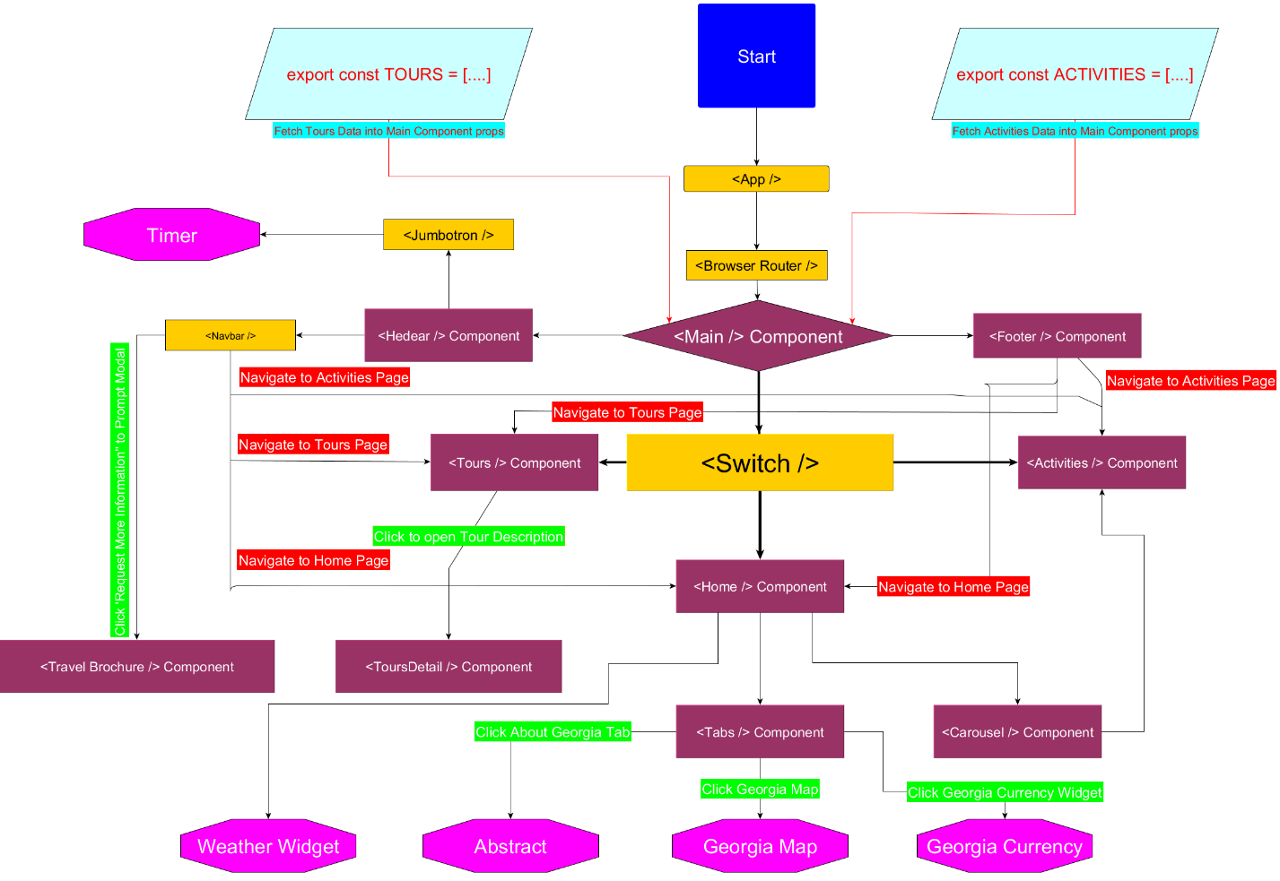

1. **References:**
   1. *Websites/books that we used* 
      1. <http://georgia.travel/>
      2. <https://www.facebook.com/georgiaandtravel/>
      3. <https://www.youtube.com/user/GeorgiaAndTravel>
      4. <https://www.youtube.com/watch?v=3vm6JZTN61Y>
      5. <https://www.pinterest.com/traveltogeorgia/>
      6. <https://twitter.com/georgiaandtrave>l

* + 1. <https://www.tripadvisor.com/Attractions-g294194-Activities-Georgia.html>
    2. <https://www.gotravelyourway.com/2013/11/12/8-reasons-to-travel-to-georgia-and-tbilisi/>